1 Kbit EEPROM

K446VG5 is the IC manufactured under the CMOS technology.

Features

- 1024 bits EEPROM communicates with the economy of one signal plus ground
- Unique, one-time write protection 64-bit registration number (8-bit family code + 48-bit serial number + 8-bit CRC tester) assures traceability
- Built-in multidrop controller ensures compatibility with other MicroLAN™ products
- EEPROM partitioned into four 256-bit pages for randomly accessing packetized data records
- Reduces control, address, data, power and programming signals to a single data pin
- Directly connects to a single port pin of a microprocessor and communicates at up to 16.3k bits per second
- Write voltage range of 4.0V to 4.5V from: -10°C to +70°C
- Read voltage range of 2.5V to 5.3V from: -10°C to +70°C
- Burn voltage 11.0V from: -10°C to + 70°C

SILICON LABEL DESCRIPTION

The K1446VG5 1 kbit Memory identifies and stores relevant information about the product to which it is associated. This lot or product-specific information can be accessed with minimal interface-for example, a single port pin of a microcontroller. The K1446VG5 consists of a one-time write protection registration number that includes a unique 48-bit serial number, an 8-bit CRC, and an 8-bit Family Code plus 1K-bit of EEPROM. The power to program and read the K1446VG5 is derived entirely from the 1-Wire TM communication line. Data is transferred serially via the 1-Wire protocol which requires only a single data lead and a ground return. The entire device can be programmed and then write-protected if desired. Alternatively, the part may be programmed multiple times with new data. The 48- bit serial number that is one-time write protection into each K1446VG5 provides identity which allows for traceability. Typical applications include storage of calibration constants, maintenance records, asset tracking, product revision status, and access codes.

OVERVIEW

The block diagram in Figure 1 shows the relationships between the major control and memory sections of the K1446VG5. The K1446VG5 has three main data components: 1) 64-bit one-time write protection EEPROM, 2) 1024-bit EEPROM, and 3) EEPROM Status Bytes. The device derives its power for read operations entirely from the 1-Wire communication line by storing energy on an internal capacitor during periods of time when the signal line is high and continues to operate off of this "parasite" power source during the low times of the 1-Wire line until it returns high to replenish the parasite (capacitor) supply. The hierarchical structure of the 1-Wire protocol is shown in Figure 2. The bus master must first provide one of the six ROM Function Commands: 1) Read ROM, 2) Match ROM, 3) Search ROM, 4) Skip ROM, 5) Write ROM, 6) Block ROM. These commands operate on the 64-bit one-time write protection EEPROM portion of each device and can singulate a specific device if many are present on the 1-Wire line as well as indicate to the bus master how many and what types of devices are present. The protocol required for these ROM Function Commands is described in Figure 9. After a ROM Function Command is successfully executed, the memory functions that operate on the EEPROM portions of the K1446VG5 become accessible and the bus master may issue any one of the five Memory Function Commands specific to the K1446VG5 to read or program the various data fields. The protocol for these Memory Function Commands is described in Figure 6. All data is read and written least significant bit first.

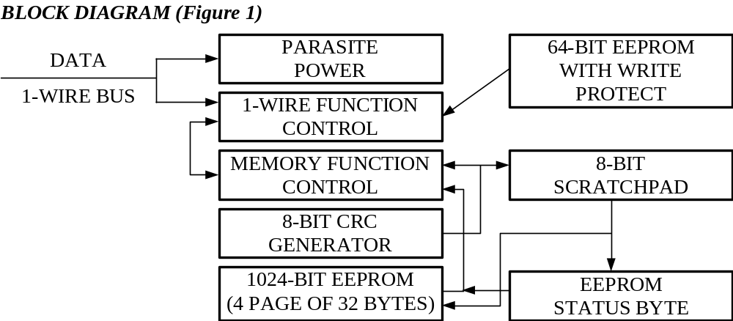

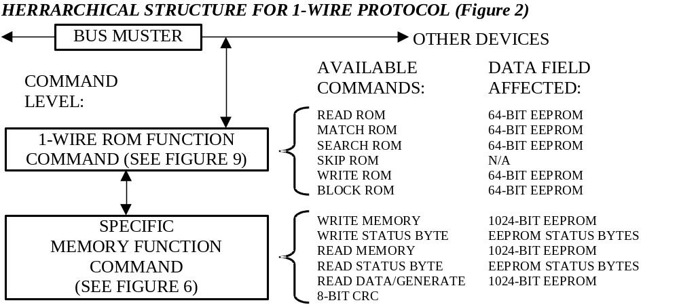

64-BIT ONE-TIME WRITE PROTECTION EEPROM

Each K1446VG5 contains a unique EEPROM code that is 64 bits long. The first eight bits are a 1-Wire family code. The next 48 bits are a unique serial number. The last eight bits are a CRC of the first 56 bits (See Figure 3). The 64-bit one-time write protection EEPROM and ROM Function Control section allow the K1446VG5 to operate as a 1-Wire device and follow the 1-Wire protocol detailed in the section "1-Wire Bus System". The memory functions required to read and program the EEPROM sections of the K1446VG5 are not accessible until the ROM function protocol has been satisfied. This protocol is described in the ROM functions flow chart (Figure 9). The 1-Wire bus master must first provide one of four ROM function commands: 1) Read ROM, 2) Match ROM, 3) Search ROM, or 4) Skip ROM. After a ROM function sequence has been successfully executed, the bus master may then provide any one of the memory function commands specific to the K1446VG5 (Figure 6). The 1-Wire CRC of the ROM is generated using the polynomial X8 + X5 + X4 + 1. Figure 4 shows a hardware implementation of this CRC generator. The shift register acting as the CRC accumulator is initialised to zero. Then starting with the least significant bit of the family code, one bit at a time is shifted in. After the eighth bit of the family code has been entered, then the serial number is entered. After the 48th bit of the serial number has been entered, the shift register contains the CRC value. Shifting in the eight bits of CRC should return the shift register to all zeroes. There are additional two ROM function commands: 4)Write ROM - writing unique number, 5) Block ROM - protection unique number from changing.

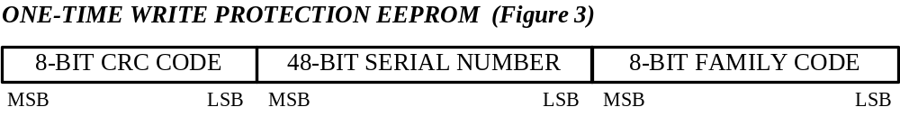

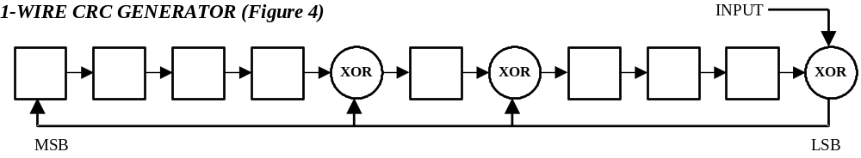

1024-BITS EEPROM

The memory map in Figure 5 shows the 1024-bit EEPROM section of the K1446VG5 which is configured as four pages of 32 bytes each. The 8-bit scratchpad is an additional register that acts as a buffer when programming the memory. Data is first written to the scratchpad and then verified by reading an 8-bit CRC from the K1446VG5 that confirms proper receipt of the data. If the buffer contents are correct, a programming pulse should be applied and the byte of data will be written into the selected address in memory. This process insures data integrity when programming the memory. The details for reading and programming the 1024-bit EEPROM portion of the K1446VG5 are given in the Memory Function Commands section.

EEPROM STATUS BYTES

In addition to the 1024 bits of data memory the K1446VG5 provides 64 bits of Status Memory accessible with separate commands. The EEPROM Status Bytes can be read or programmed to indicate various conditions to the software interrogating the K1446VG5. The first byte of the EEPROM Status Memory contain the Write Protect Page bits which inhibit programming of the corresponding page in the 1024-bit main memory area if the appropriate write protection bit is programmed (0). Once a bit has been programmed (0) in the Write Protect Page byte, the entire 32 byte page that corresponds to that bit can no longer be altered but may still be read. The details for reading and programming the EEPROM status memory portion of the K1446VG5 are given in the Memory Function Commands section.

MEMORY FUNCTION COMMANDS

The “Memory Function Flow Chart” (Figure 6) describes the protocols necessary for accessing the various data fields within the K1446VG5. The Memory Function Control section, 8-bit scratchpad combine to interpret the commands issued by the bus master and create the correct control signals within the device. A three-byte protocol is issued by the bus master. It is comprised of a command byte to determine the type of operation and two address bytes to determine the specific starting byte location within a data field. The command byte indicates if the device is to be read or written. Writing data involves not only issuing the correct command sequence by also providing a programming pulse at the appropriate times. To execute a write sequence, a byte of data is first loaded into the scratchpad and then programmed into the selected address. Write sequences always occur a byte at a time. To execute a read sequence, the starting address is issued by the bus master and data is read from the part beginning at that initial location and continuing to the end of the selected data field or until a reset sequence is issued. All bits transferred to the K1446VG5 and received back by the bus master are sent least significant bit first.
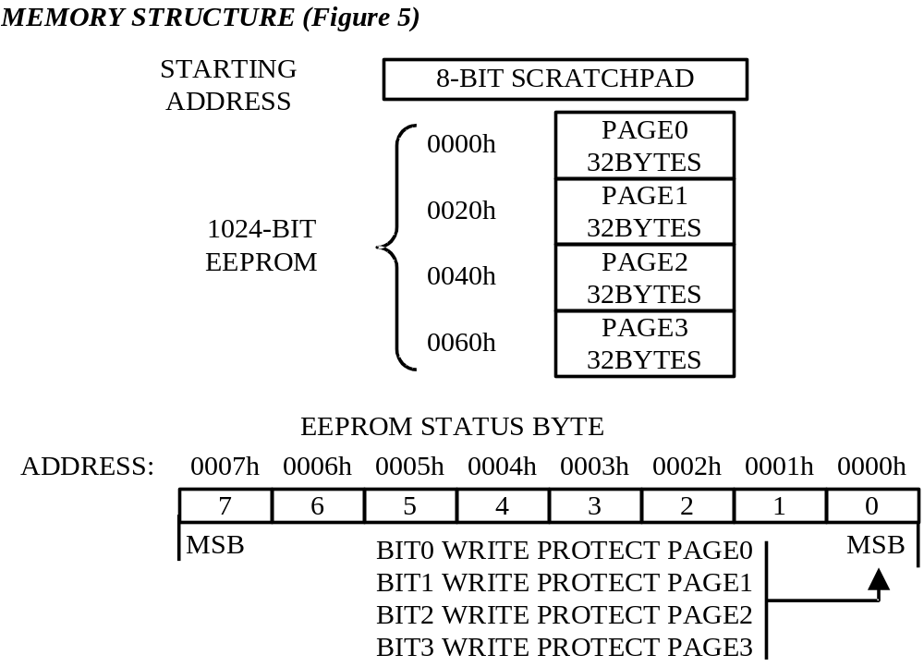

READ MEMORY [FOH]

The Read Memory command is used to read data from the 1024-bit EEPROM data field. The bus master follows the command byte with a two-byte address (TA1=(T7: TO), TA2=(T15:T8)) that indicates a starting byte location within the data field. An 8-bit CRC of the command byte and address bytes is computed by the K1446VG5 and read back by the bus master to confirm that the correct command word and starting address were received. If the CRC read by the bus master is incorrect, a Reset Pulse must be issued and the entire sequence must be repeated. If the CRC received by the bus master is correct, the bus master issues read time slots and receives data from the K1446VG5 starting at the initial address and continuing until the end of the 1024-bit data field is reached or until a Reset Pulse is issued. If reading occurs through the end of memory space, the bus master may issue eight additional read time slots and the K1446VG5 will respond with a 8-bit CRC of all data bytes read from the initial starting byte through the last byte of memory. After the CRC is received by the bus master, any subsequent read time slots will appear as logical 1s until a Reset Pulse is issued. Any reads ended by a Reset Pulse prior to reaching the end of memory will not have the 8-bit CRC available. Typically a 16-bit CRC would be stored with each page of data to insure rapid, error-free data transfers that eliminate having to read a page multiple times to deter-mine if the received data is correct or not. If CRC values are imbedded within the data, a Reset Pulse may be issued at the end of memory space during a Read Memory command.

READ STATUS [AAH]

The Read Status command is used to read data from the EEPROM Status data field. The bus master follows the command byte with a two-byte address (TA1=(T7: TO), TA2=(T15: T8)) that indicates a starting byte location within the data field. An 8-bit CRC of the command byte and address bytes is computed by the K1446VG5 and read back by the bus master to confirm that the correct command word and starting address were received. If the CRC read by the bus master is incorrect, a Reset Pulse must be issued and the entire sequence must be repeated. If the CRC received by the bus master is correct, the bus master issues read time slots and receives data from the K1446VG5 starting at the supplied address and continuing until the end of the EEPROM Status data field is reached. At that point the bus master will receive an 8-bit CRC that is the result of shifting into the CRC generator all of the data bytes from the initial starting byte through the final byte. This feature is provided since the EEPROM Status information may change over time making it impossible to program the data once and include an accompanying CRC that will always be valid. Therefore, the Read Status command supplies an 8-bit CRC that is based on and always is consistent with the current data stored in the EEPROM Status data field. After the 8-bit CRC is read, the bus master will receive logical 1s from the K1446VG5 until a Reset Pulse is issued. The Read Status command sequence can be ended at any point by issuing a Reset Pulse.

READ DATA/GENERATE 8-BIT CRC [C3H]

The Read Data/Generate 8-bit CRC command is used to read data from the 1024-bit EEPROM data field. The bus master follows the command byte with a two-byte address (TA1=(T7: TO), TA2=(T15: T8)) that indicates a starting byte location within the data field. An 8-bit CRC of the command byte and address bytes is computed by the K1446VG5 and read back by the bus master to confirm that the correct command word and starting address were received. If the CRC read by the bus master is incorrect, a Reset Pulse must be issued and the entire sequence must be repeated. If the CRC received by the bus master is correct, the bus master issues read time slots and receive data from the K1446VG5 starting at the initial address and continuing until the end of a 32-byte page is reached. At that point the bus master will send eight additional read time slots and receive an 8-bit CRC that is the result of shifting into the CRC generator all of the data bytes from the initial starting byte to the last byte of the current page. Once the 8-bit CRC has been received, data is again read from the 1024-bit EEPROM data field starting at the next page. This sequence will continue until the final page and its accompanying CRC are read by the bus master. Thus each page of data can be considered to be 33 bytes long, the 32 bytes of user-programmed EEPROM data and an 8-bit CRC that gets generated automatically at the end of each page. This type of read differs from the Read Memory command which simple reads each page until the end of address space is reached. The Read Memory command only generates an 8-bit CRC at the end of memory space that often might be ignored, since in many applications the user would store a 16-bit CRC with the data itself in each page of the 1024-bit EEPROM data field at the time the page was programmed. The Read Data/Generate 8-bit CRC command pro-vides and alternate read capability for applications that are “bit-oriented” rather than “page oriented” where the 1024-but EEPROM information may change over time within a page boundary making it impossible to program the page once and include an accompanying CRC that will always be valid. Therefore, the Read Data/Gener-ate 8-bit CRC command concludes each page with the K1446VG5 generating and supplying an 8-bit CRC that is based on and therefore is always consistent with the current data stored in each page of the 1024-bit EEPROM data field. After the 8-bit CRC of the last page is read, the bus master will receive logical 1s from the K1446VG5 until a Reset Pulse is issued. The Read Data/Generate 8-Bit CRC command sequence can be exited at any point by issuing a Reset Pulse.

WRITE MEMORY [OFH]

The Write Memory command is used to program the 1024-bit EEPROM data field. The bus master will follow the command byte with a two-byte starting address (TA1=(T7: TO), TA2=(T15: T8)) and a byte of data (D7: DO). An 8-bit CRC of the command byte, address bytes, and data byte is computed by the K1446VG5 and read back by the bus master to confirm that the correct command word, starting address, and data byte were received. The highest starting address within the K1446VG5 is 007FH. If the CRC read by the bus master is incorrect, a Reset Pulse must be issued and the entire sequence must be repeated. If the CRC received by the bus master is correct, the bus master issues a programming pulse. For each bit in the data byte provided by the bus master that is set to a logical 0, the corresponding bit in the selected byte of the 1024-bit EEPROM will be programmed to a logical 0 after the programming pulse has been applied at that byte location. After the programming pulse is applied the bus master issues eight read time slots to verify that the appropriate bits have been programmed. The K1446VG5 responds with the data from the selected EEPROM address sent least significant bit first. If the EEPROM data byte contains 1s(0s) in bit positions where the byte issued by the master contains 0s(1s), a Reset Pulse should be issued and the current byte address should be programmed again. If the K1446VG5 EEPROM data byte contains 0s and 1s in the same bit positions as the data byte, the programming was successful and the K1446VG5 will automatically increment its address counter to select the next byte in the 1024-bit EEPROM data field. The least significant byte of the new two-byte address will also be loaded into the 8-bit CRC generator as a starting value. The bus master will issue the next byte of data using eight write time slots. As the K1446VG5 receives this byte of data into the scratchpad, it also shifts the data into the CRC generator that has been preloaded with the LSB of the current address and the result is an 8-bit CRC of the new data byte and the LSB of the new address. After supplying the data byte, the bus master will read this 8-bit CRC from the K1446VG5 with eight read time slots to confirm that the address incremented properly and the data byte was received correctly. If the CRC is incorrect, a Reset Pulse must be issued and the Write Memory command sequence must be restarted. If the CRC is correct, the bus master will issue a programming pulse and the selected byte in memory will be programmed. Note that the initial pass through the Write Memory flow chart will generate an 8-bit CRC value that is the result of shifting the command byte into the CRC generator, followed by the two address bytes, and finally the data byte. Subsequent passes through the Write Memory flow chart due to the K1446VG5 automatically incrementing its address counter will generate an 8-bit CRC that is the result of loading (not shifting) the LSB of the new (incremented) address into the CRC generator and then shifting in the new data byte. For both of these cases, the decision to continue (to apply a program pulse to the K1446VG5) is made entirely by the bus master, since the K1446VG5 will not be able to determine if the 8-bit CRC calculated by the bus master agrees with the 8-bit CRC calculated by the K1446VG5. If an incorrect CRC is ignored and a program pulse is applied by the bus master, incorrect programming could occur within the K1446VG5. Also note that the K1446VG5 will always increment its internal address counter after the receipt of the eight read time slots used to confirm the programming of the selected EEPROM byte. The decision to continue is again made entirely by the bus master, therefore if the EEPROM data byte does not match the supplied data byte but the master continues with the Write Memory command, incorrect programming could occur within the K1446VG5. The Write Memory command sequence can be exited at any point by issuing a Reset Pulse.

WRITE STATUS [55H]

The Write Status command is used to program the EEPROM Status data field. The bus master will follow the command byte with a two-byte starting address (TA1=(T7: TO), TA2=(T15: T8)) and a byte of status data (D7: DO). An 8-bit CRC of the command byte, address bytes, and data byte is computed by the K1446VG5 and read back by the bus master to confirm that the correct command word, starting address, and data byte were received. If the CRC read by the bus master is incorrect, a Reset Pulse must be issued and the entire sequence must be repeated. If the CRC received by the bus master is correct, a programming pulse is issued by the bus master. For each bit in the data byte provided by the bus master that is set to a logical 0 (1) the corresponding bit in the selected byte of the EEPROM Status data field will be programmed to a logical 0 (1) after the programming pulse has been applied at the byte location. After the programming pulse is applied the bus master issues eight read time slots to verify that the appropriate bits have been programmed. The K1446VG5 responds with the data from the selected EEPROM Status address sent least significant bit first, if the EEPROM Status Byte contains 1s (0s) in bit positions where the byte issued by the master contained Os (1s), a Reset Pulse should be issued and the current byte address should be programmed again. If the K1446VG5 EEPROM Status Byte contains 0s and 1 s in the same bit positions as the data byte, the programming was successful and the K1446VG5 will automatically increment its address counter to select the next byte in the EEPROM Status data field. The least significant byte of the new two-byte address will also be loaded into the 8-bit CRC generator as a starting value. The bus master will issue the next byte of data using eight write time slots. As the K1446VG5 receives this byte of data into the scratchpad, it also shifts the data into the CRC generator that has been preloaded with the LSB of the current address and the result is an 8-bit CRC of the new data byte and the LSB of the new address. After supplying the data byte, the bus master will read this 8-bit CRC from the K1446VG5 with eight read time slots to confirm that the address incremented properly and the data byte was received correctly. If the CRC is incorrect, a Reset Pulse must be issued and the Write Status command sequence must be restarted. If the CRC is correct, the bus master will issue a programming pulse and the selected byte in memory will be programmed. Note that the initial pass through the Write Status flow chart will generate an 8-bit CRC value that is the result of shifting the command byte into the CRC generator, followed by the two address bytes, and finally the data byte.
Subsequent passes through the Write Status flow chart due to the K1446VG5 automatically incrementing its address counter will generate an 8-bit CRC that is the result of loading (not shifting) the LSB of the new (incremented) address into the CRC generator and then shifting in the new data byte. For both of these cases, the decision to continue (to apply a program pulse to the K1446VG5) is made entirely by the bus master, since the K1446VG5 will not be able to determine if the 8-bit CRC calculated by the bus master agrees with the 8-bit CRC calculated by the K1446VG5. If an incorrect CRC is ignored and a program pulse is applied by the bus master, incorrect programming could occur within the K1446VG5. Also note that the K1446VG5 will always increment its internal address counter after the receipt of the eight read time slots used to confirm the programming of the selected EEPROM byte. The decision to continue is again made entirely by the bus master, therefore if the EEPROM data byte does not match the supplied data byte but the master continues with the Write Status command, incorrect programming could occur within the K1446VG5. The Write Status command sequence can be ended at any point by issuing a Reset Pulse.

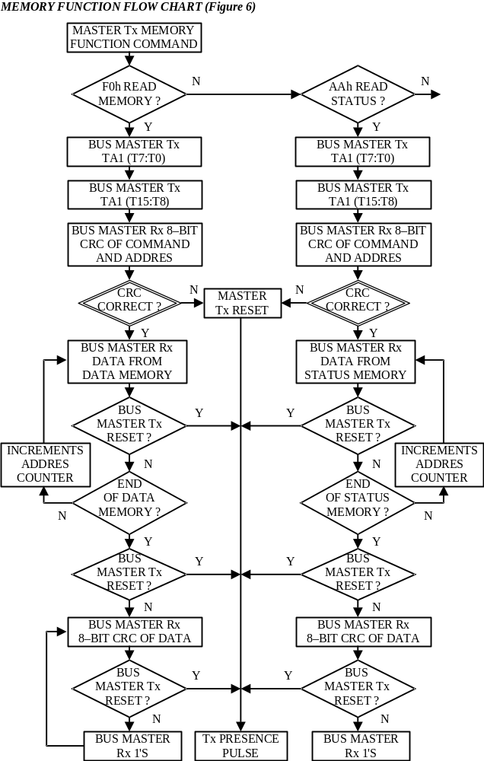

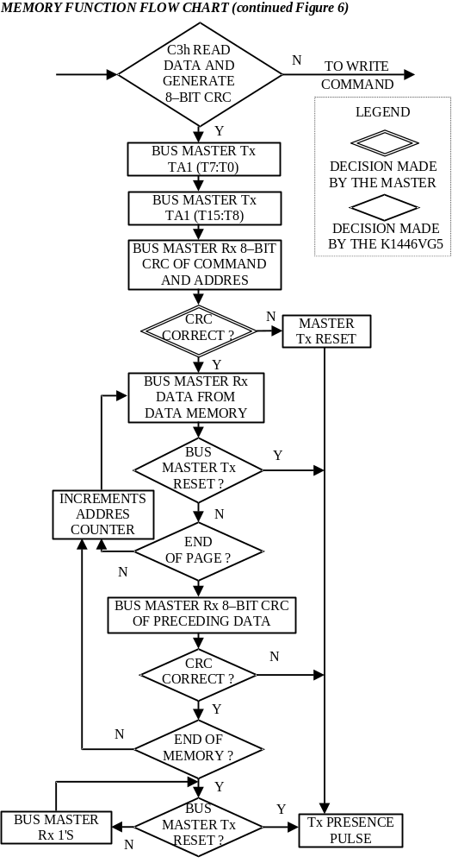

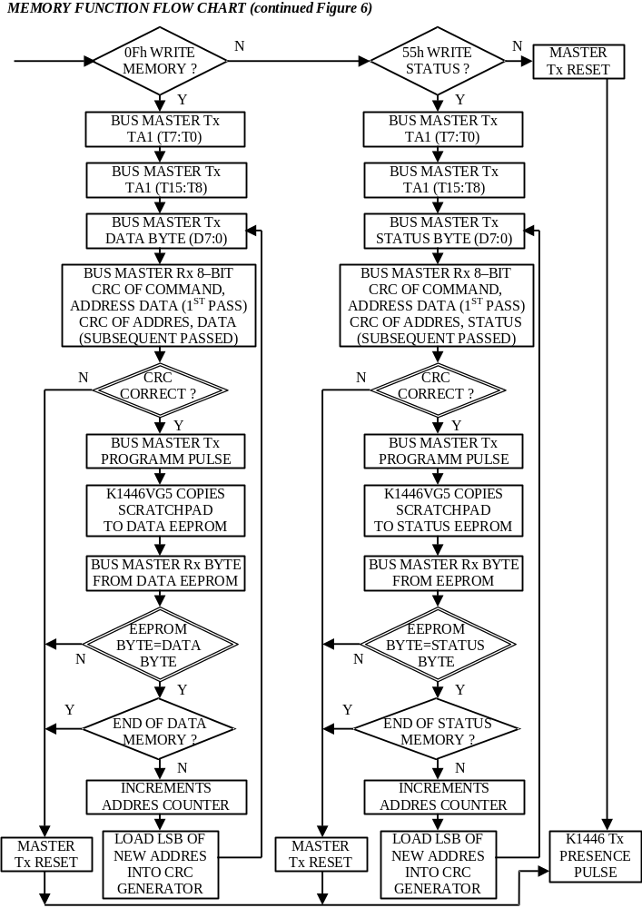

1-WIRE BUS SYSTEM

The 1-Wire bus is a system which has a single bus master and one or more slaves. In all instances, the K1446VG5 is a slave device. The bus master is typically a microcontroller. The discussion of this bus system is broken down into three topics: hardware configuration, transaction sequence, and 1-Wire signalling (signal type and timing). A 1- Wire protocol defines bus transactions in terms of the bus state during specified time slots that are initiated on the falling edge of sync pulses from the bus master.

Hardware Configuration

The 1-Wire bus has only a single line by definition; it is important that each device on the bus be able to drive it at the appropriate time. To facilitate this, each device attached to the 1-Wire bus must have an open drain connection or 3-state outputs. The K1446VG5 is an open drain part with an internal circuit equivalent to that shown in Figure 7. The bus master can be the same equivalent circuit. If a bi-directional pin is not available, separate output and input pins can be tied together. The writer electrical circuit shown on the figure 8. A multidrop bus consists of a 1-Wire bus with multiple slaves attached. At regular speed the 1-Wire bus has a maximum data rate of 16.3k bits per second. The idle state for the 1-Wire bus is high. If, for any reason, a transaction needs to be suspended, the bus MUST be left in the idle state if the transaction is to resume. If this does not occur and the bus is left low for more than 120us (regular speed), one or more of the devices on the bus may be reset.

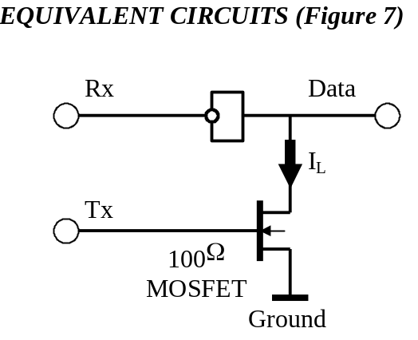
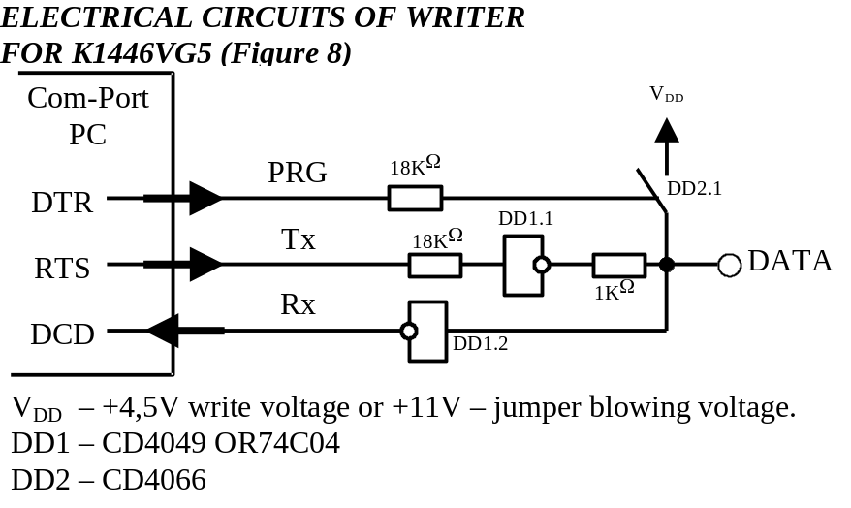

Transaction Sequence

The sequence for accessing the K1446VG5 via the 1-Wire port is as follows:
- Initialisation
- ROM Function Command
- Memory Function Command
- Read/Write Memory/Status

INITIALIZATION

All transactions on the 1-Wire bus begin with an initialisation sequence. The initialisation sequence consists of a reset pulse transmitted by the bus master followed by a presence pulse(s) transmitted by the slave(s). The presence pulse lets the bus master know that the K1446VG5 is on the bus and is ready to operate. For more details, see the "1-Wire Signalling" section.

ROM FUNCTION COMMANDS

Once the bus master has detected a presence, it can issue one of the six ROM function commands. All ROM function commands are eight bits long. A list of these commands follows (refer to flowchart in Figure 9):

Read ROM [33H]

This command allows the bus master to read the K1446VG5's 8-bit family code, unique 48-bit serial number, and 8-bit CRC. This command can be used only if there is a single K1446VG5 on the bus. If more than one slave is present on the bus, a data collision will occur when all slaves try to transmit at the same time (open drain will produce a wired- AND result).

Match ROM [55H]

The match ROM command, followed by a 64-bit ROM sequence, allows the bus master to address a specific K1446VG5 on a multidrop bus. Only the K1446VG5 that exactly matches the 64-bit ROM sequence will respond to the subsequent memory function command. All slaves that do not match the 64-bit ROM sequence will wait for a reset pulse. This command can be used with a single or multiple devices on the bus.

Skip ROM [CCH]

This command can save time in a single drop bus system by allowing the bus master to access the memory functions without providing the 64-bit ROM code. If more than one slave is present on the bus and a read command is issued following the Skip ROM command, data collision will occur on the bus as multiple slaves transmit simultaneously (open drain pull-downs will produce a wired-AND result).

Search ROM [FOH]

When a system is initially brought up, the bus master might not know the number of devices on the 1-Wire bus or their 64-bit ROM codes. The search ROM command allows the bus master to use a process of elimination to identify the 64-bit ROM codes of all slave devices on the bus. The ROM search process is the repetition of a simple 3-step routine: read a bit, read the complement of the bit, then write the desired value of that bit. The bus master performs this simple, 3-step routine on each bit of the ROM. After one complete pass, the bus master knows the contents of the ROM in one device. The remaining number of devices and their ROM codes may be identified by additional passes.

Write ROM [3CH]

Command allows to write a unique 64-bit number. The command can be executed only with not more than one K1446VG5 IC connected to the bus, otherwise a failure can occur.

Block ROM [35H]

The command ensures one-time write protection of the unique 64-bit number. After the Block ROM command execution it is not possible to execute a Write ROM command.

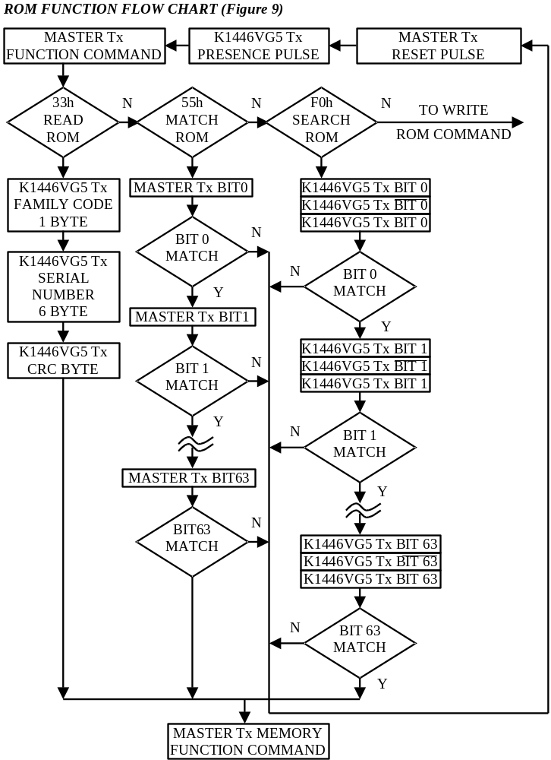

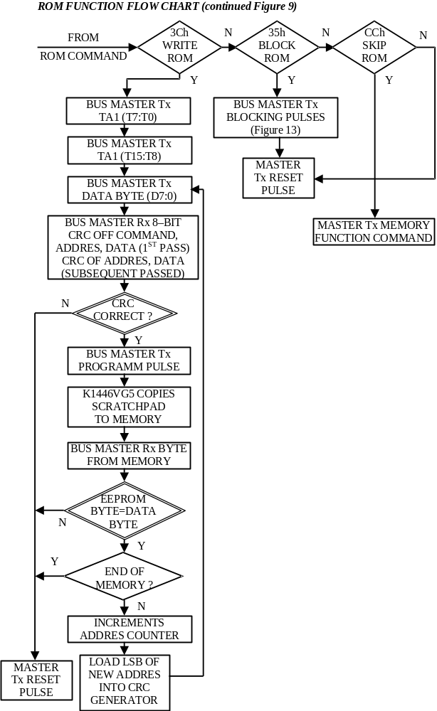

1-Wire Signaling

The K1446VG5 requires strict protocols to insure data integrity. The protocol consists of six types of signalling on one line: Reset Sequence with Reset Pulse and Presence Pulse, Write 0, Write 1, Read Data, Program Pulse and Blocking Pulse. All these signals except presence pulse are initiated by the bus master. The initialisation sequence required to begin any communication with the K1446VG5 is shown in Figure 10. A Reset Pulse followed by a Presence Pulse indicates the K1446VG5 is ready to accept a ROM command. The bus master transmits (TX) a reset pulse (t_{RSTL}, minimum 480). The bus master then releases the line and goes into receive mode (RX). The 1-Wire bus is pulled to a high state via the pull-up resistor. After detecting the rising edge on the data pin, the K1446VG5 waits (t_{PDH}, 15…60 us) and then transmits the presence pulse (t_{PDL}: 60…160us).

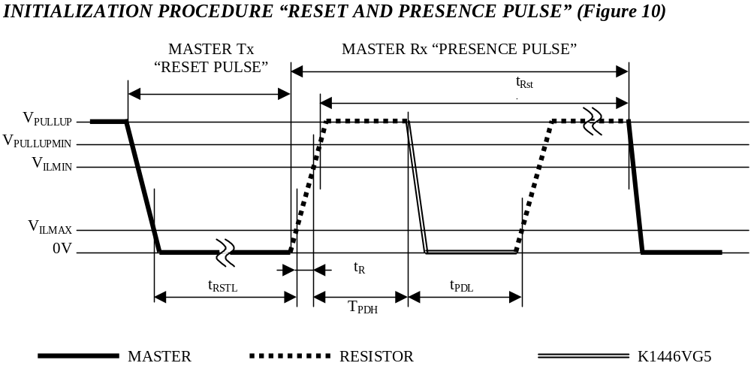

Read/Write Time Slots

The definitions of write and read time slots are illustrated in Figure 11. All time slots are initiated by the master driving the data line low. The falling edge of the data line synchronizes the K1446VG5 to the master by triggering a delay circuit in the K1446VG5. During write time slots, the delay circuit determines when the K1446VG5 will sample the data line. For a read data time slot, if a "0" is to be transmitted, the delay circuit determines how long the K1446VG5 will hold the data line low overriding the 1 generated by the master. If the data bit is a "1", the device will leave the read data time slot unchanged.

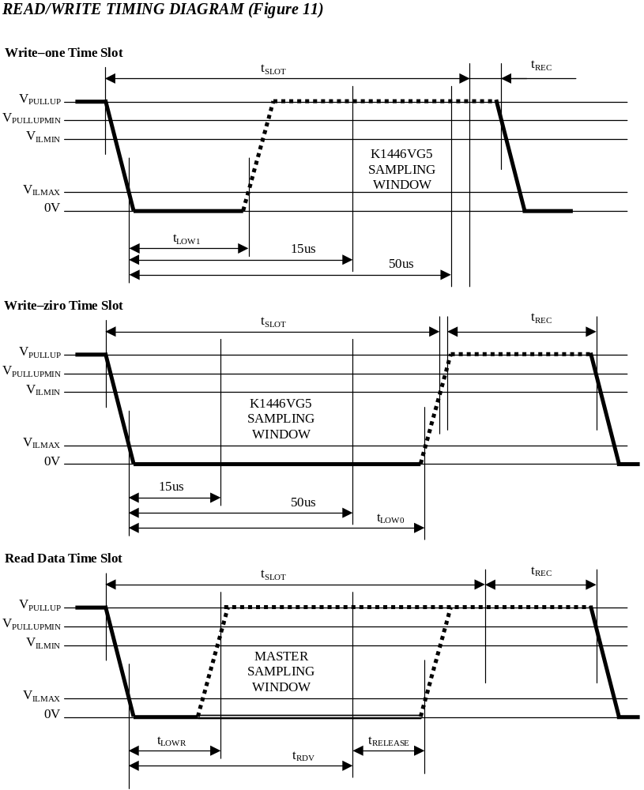

PROGRAM PULSE

To copy data from the 8-bit scratchpad to the 1024-bit EEPROM Memory or Status Memory, a program pulse (Figure 12) is applied to the data line after the bus master has confirmed that the CRC for the current byte is correct.

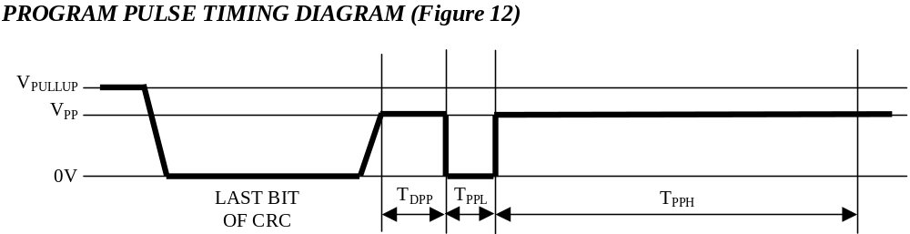

BLOCKING PULSE

To ensure a write protection of 64-bit number Blocking pulse (Figure 13) is used. During this Blocking pulse 8V voltage is applied to the bus for 100ms.

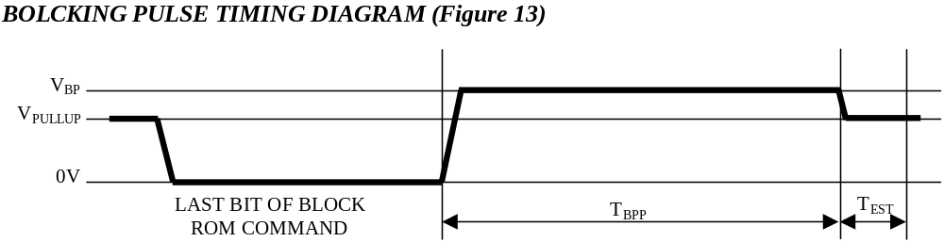

CRC GENERATION

The K1446VG5 has an 8-bit CRC stored in the most significant byte of the 64-bit ROM. The bus master can compute a CRC value from the first 56 bits of the 64-bit ROM and compare it to the value stored within the K1446VG5 to determine if the ROM data has been received error-free by the bus master. The equivalent polynomial function of this CRC is: X⁸+X⁵+X⁴+1. Under certain conditions, the K1446VG5 also generates an 8-bit CRC value using the same polynomial function shown above and provides this value to the bus master to validate the transfer of command, address, and data bytes from the bus master to the K1446VG5. The Memory Function Flow Chart of Figure 6 indicates that the K1446VG5 computes an 8-bit CRC for the command, address, and data bytes received for the Write Memory and the Write Status commands and then outputs this value to the bus master to confirm proper transfer. Similarly the K1446VG5 computes an 8-bit CRC for the command and address bytes received from the bus master for the Read Memory, Read Status, and Read Data/Generate 8-Bit CRC commands to confirm that these bytes have been received correctly. The CRC generator on the K1446VG5 is also used to provide verification of error-free data transfer as each page of data from the 1024-bit EEPROM is sent to the bus master during a Read Data/Generate 8-Bit CRC command, and for the eight bytes of information in the status memory field.
In each case where a CRC is used for data transfer validation, the bus master must calculate a CRC value using the polynomial function given above and compare the calculated value to either the 8-bit CRC value stored in the 64-bit ROM portion of the K1446VG5 (for ROM reads) or the 8-bit CRC value computed within the K1446VG5. The comparison of CRC values and decision to continue with an operation are determined entirely by the bus master. There is no circuitry on the K1446VG5 that prevents a command sequence from proceeding if the CRC stored in or calculated by the K1446VG5 does not match the value generated by the bus master. Proper use of the CRC as outlined in the flow chart of Figure 6 can result in a communication channel with a very high level of integrity.
ABSOLUTE MAXIMUM RATINGS*

Parameter | Value
Voltage on any Pin Relative to Ground | -0.5V to+12.0V
Operating Temperature | -10°Cto+70°C

* This is a stress rating only and functional operation of the device at these or any other conditions outside those indicated in the operation sections of this specification is not implied. Exposure to absolute maximum rating conditions for extended periods of time may affect reliability.

ELECTRICAL CHARACTERISTICS (vpup =2.5V to 5.3V; -10°C to +70°C)

Parameter | Symbol | Min. | Typ. | Max. | Units | Notes
Logic 1 | VIH | 2.4 |  | VCC+0.3 | V | 1,4
Logic 0 | VI L | -0.3 |  | +0.8 | V | 1,6
Output Logic Low @ 4mA | VOL |  |  | 0.4 | V | 1
Output Logic High | VOH |  | VPUP | 5.3 | V | 1,2
Programming Voltage | VPP | 4.0 |  | 4.5 | V
Data (1-Wire) | С_{IN}/OUT |  |  | 800 | PF | 5
Burn Voltage | VBP |  | 11 |  | V
Current consumption |  |  | 10 | 30 | µA

AC ELECTRICAL CHARACTERISTICS REGULAR SPEED (vpup =2.5V to 5.3V; -10°C to +70°C)

Parameter | Symbol | Min. | Typ. | Max. | Units | Notes
Time Slot | t_{SLOT} | 50 |  | 120 | us
Write 1 Low Time | t_{LOW1} | 4 |  | 15 | us
Write 0 Low Time | t_{LOW0} | 40 |  | 120 | us
Read Data Valid | t_{RDV} |  | 15 |  | us
Release time | t_{RELEASE} | 0 | 15 | 35 | us
Recovery Time | t_{REC} | 10 |  |  | us
Reset Time High | t_{RSTH} | 480 |  |  | us | 3
Reset Time Low | t_{RSTL} | 360 |  |  | us
Presence Detect High | t_{PDH} | 15 |  | 60 | us
Presence Detect Low | t_{PDL} | 60 |  | 160 | us
Delay Program Pulse | t_{DPP} | 600 |  |  | us
Program Pulse High | t_{PPH} | 50 |  |  | ms
Program Pulse Low | t_{PPL} | 5 |  |  | us | 7
Burn Pulse High | t_{BPP} | 100 |  |  | ms
Establishment Time | t_{EST} | 4 |  |  | us

NOTES:

1. All voltages are referenced to ground.
2. VPUP = external pull-up voltage.
3. An additional reset or communication sequence cannot begin until the reset high time has expired.
4. VIH is a function of the external pull-up resistor and the VCC supply.
5. Capacitance on the data pin could be 800 pF when power is first applied. If a 1kOhm resistor is used to pull up the data line to VCC, 5 us after power has been applied the parasite capacitance will not affect normal communications.
6. Under certain low voltage conditions VILMAX may have to be reduced to as much as 0.5V to always guarantee a presence pulse.

